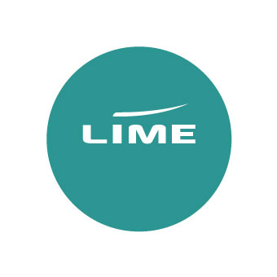
Lime x British Airways USA Incentive
Terms & Conditions

- The prize draw is open to UK operators that have a live Flights or Groups account with Lime.

- Employees of Lime, British Airways and any companies affiliated (other than a registered account) to those mentioned are not eligible to enter.
Booking incentive
- To enter our booking incentive, book British Airways flights to Boston (BOS), Cancun (CUN), Denver (DEN), Houston (IAH), Las Vegas (LAS), Los Angeles (LAX), Mexico City (MEX), Miami (MIA), New Orleans (MSY), New York (JFK), Orlando (MCO), Philadelphia (PHL), Phoenix (PHX), Portland (PDX), San Francisco (SFO), Seattle (SEA), Tampa (TPA), Washington Dulles (IAD) via Lime in any cabin between 1 September 2026 and 13 October 2026.
- We’ll track bookings and award the prize to one of our top-selling USA Tour Operator Partners. The prize will include:
- A pair of World Traveller (O class) British Airways flights to New York (JFK), subject to availability.
- 3 night stay for two people at Tempo by Hilton Time Square
- 2 night stay for two people at The Knickerbocker Time Square
- 2x VIP tickets to Top of the Rock
- 2x all access tickets to American Museum Natural History
- 2x New York CityPass which allows entry to 5 attractions
5. Winners for the booking incentive will be notified by 30 October 2026. Three date options must be provided by 14 November 2026 with a flight secured by 30 November 2026.
Destination quiz
8. All participants who complete the quiz before 13 October 2026 and answer all questions correctly will automatically be entered into a prize draw to win a £50 Gift Card of their choice, sent before 30 October 2026.
9. Winners for the destination quiz will be notified by 25 October 2026.
10. All prizes are non-changeable, non-transferable and no cash alternative is available.
11. Winners agree to have their name on Lime’s website and social platforms for promotional purposes.
12. By taking part in this incentive, you are giving permission for Lime to share your contact details with any contributing partners.
13. Winners will be required to provide a testimonial about the process and prize to be used by
Lime for promotional purposes.
14. Lime reserves the right to amend or withdraw this promotion at any time. Lime’s decision is final and considers our contributing partners.

