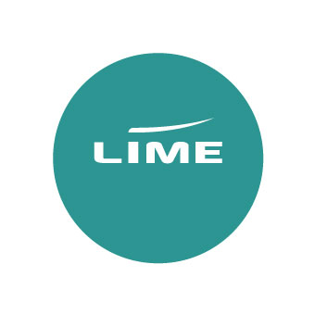
Lime x Houston Incentive
Terms & Conditions

- The prize draw is open to UK operators that have a live Flights or Groups account with Lime.
- Employees of Lime, British Airways and any companies affiliated (other than a registered account) to those mentioned are not eligible to enter.
- To enter the prize draw for one of two £250 vouchers, book British Airways flights to Houston via Lime between 4 September 2025 and 9 October 2025.
- To enter the prize draw for one of two £50 Amazon vouchers, successfully answer all questions in the Houston quiz correctly by 9 October 2025.
- Prizes to be awarded:
One of two £250 vouchers of your choice awarded to our top bookers.

One of two £50 Amazon vouchers selected at random.

Winners for the booking incentive will be notified by the end of November 2025.
Prize specifics:
- Prizes are non-changeable, non-transferable and no cash alternative is available.
- Winners agree to have their name on Lime’s website and social platforms for promotional purposes.
- By taking part in this incentive, you are giving permission for Lime to share your contact details with any contributing partners.
- Winners will be required to provide a testimonial about the process and prize to be used by
Lime for promotional purposes.
- Lime reserves the right to amend or withdraw this promotion at any time.
- Lime’s decision is final and considers our contributing partners.
